**Finance Dashboard**

1. **Problem Statement:**

* Financial Analysis is a Business enforcement duty that involves a systematic patterns and trends in Financial State. Pattern information can help Company deploy resources more effectively and detectives.

**Solution:**

* This solution empowers financial personnel to make informed decisions regarding the financial performance of your company. Developed using the latest PowerBI functionality, this solution is easy-to-use and highly customisable to match your company’s branding.
* With our Financial Dashboards, you can effectively monitor and evaluate relevant financial KPIs and metrics in a set of interactive and easy-to-use visualisations.

1. **About Dataset:**

* This dataset contains Financial reported. In this report, information about Financial period, cost, expense, tax, current assets, Current Liabilities, total assets, total liabilities, interest, cost center, legal entity, balance sheet, income statement etc.

1. **Data-Cleaning:**

* Use first row as header.(Change Type)

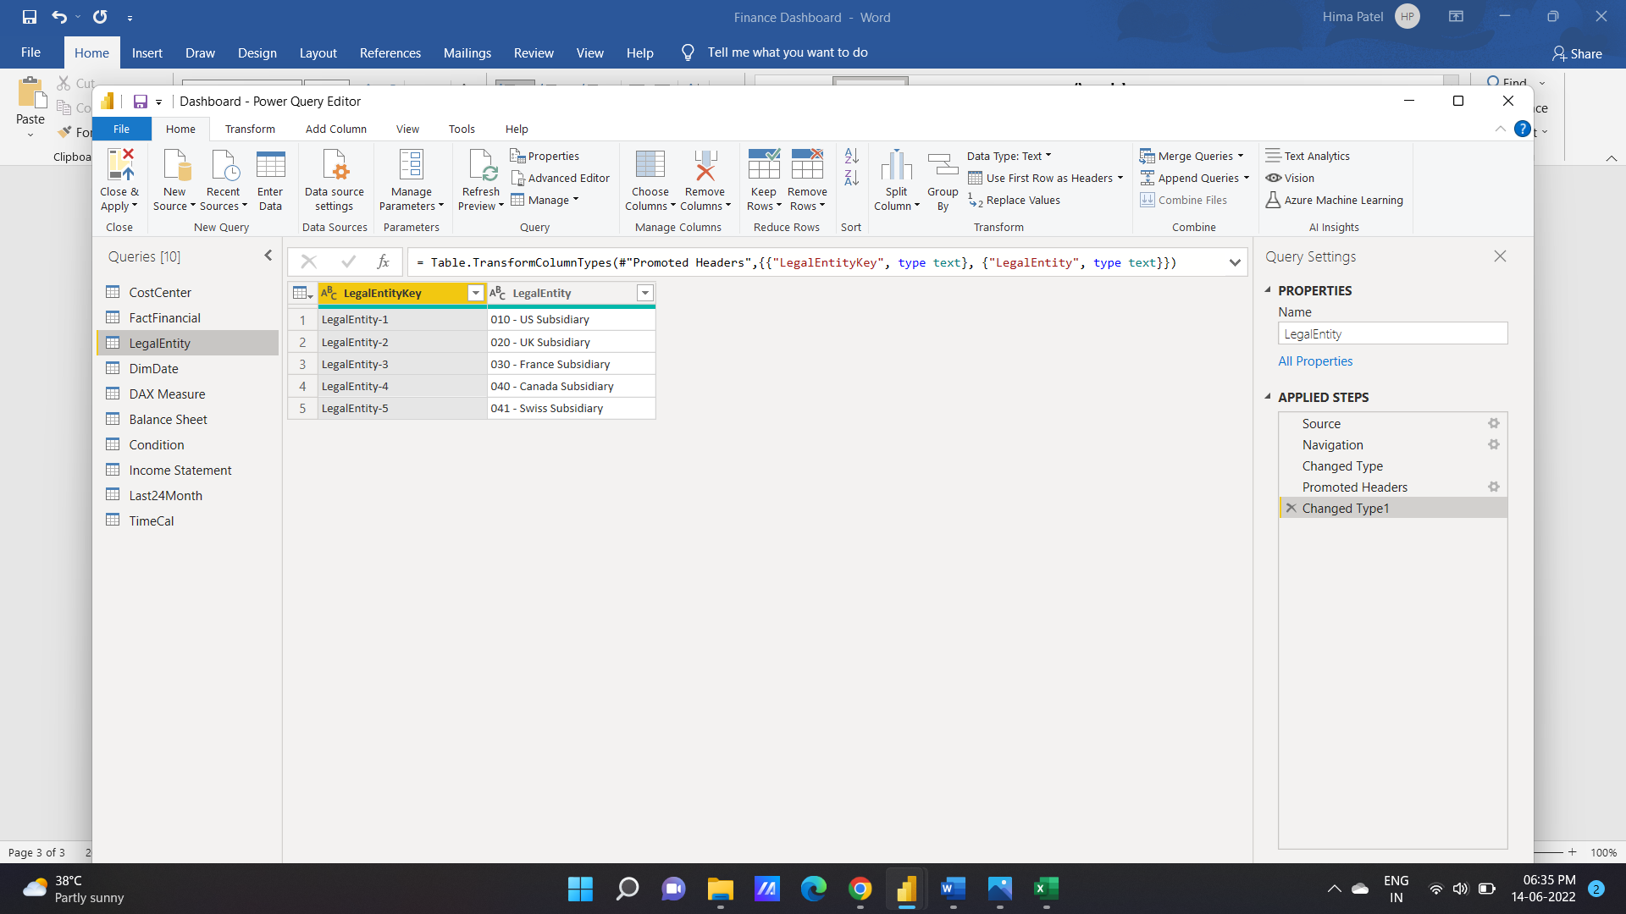

* Create new query for date (DimDate).

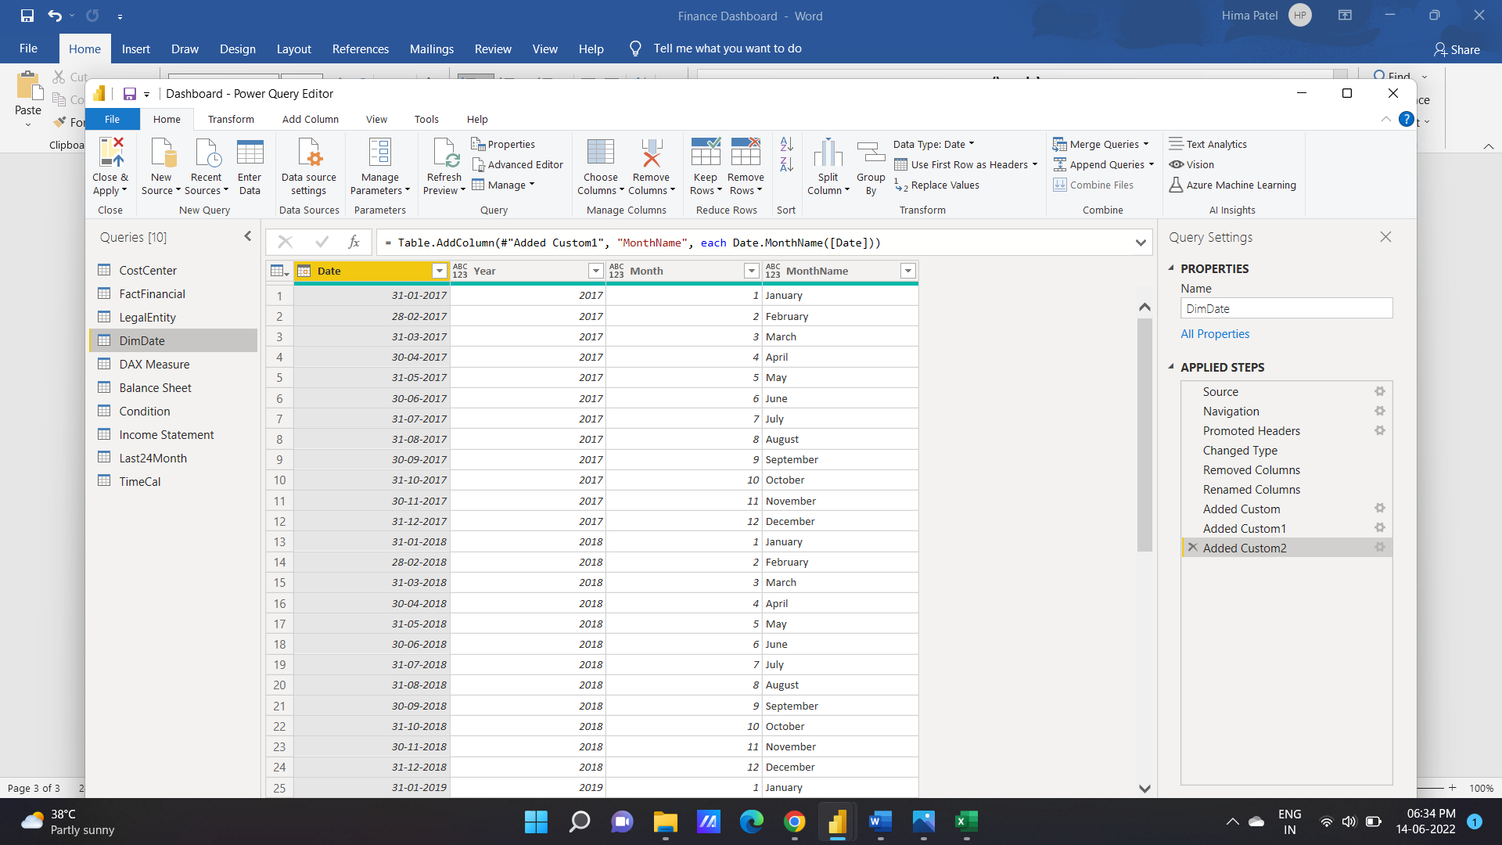

Same as Dimdate query, create -> TimeCal, Last24Month, Income Statement, Condition, Balance sheet, Dax measures.

1. **Calculated Functions:**

* SelectedValue:

SELECTEDVALUE(<columnName>[, <alternateResult>])

Returns the value when the context for columnName has been filtered down to one distinct value only. Otherwise returns alternateResult.

To learn more about best practices when using SELECTEDVALUE, see [Use SELECTEDVALUE instead of VALUES in DAX](https://docs.microsoft.com/en-us/dax/best-practices/dax-selectedvalue).

This function is not supported for use in DirectQuery mode when used in calculated columns or row-level security (RLS) rules.

* SUM:

Adds all the numbers in a column.

Syntax: SUM ( < Column_Name > )

Example: total = SUM(Film[RunTimeMinutes])

* Divide:

DIVIDE(<numerator>, <denominator> [,<alternateresult>])

As a data modeler, when you write a DAX expression to divide a numerator by a denominator, you can choose to use the [DIVIDE](https://docs.microsoft.com/en-us/dax/divide-function-dax) function or the divide operator (/ - forward slash).

When using the DIVIDE function, you must pass in numerator and denominator expressions. Optionally, you can pass in a value that represents an alternate result.

* Var:

VAR <name> = <expression>

Stores the result of an expression as a named variable, which can then be passed as an argument to other measure expressions. Once resultant values have been calculated for a variable expression, those values do not change, even if the variable is referenced in another expression.

1. **KPI’S:**

In which followings KPIS are present :

1. **Total Revenues**

Total revenue, also known as gross revenue, is your total revenue from recurring ([MRR](https://finmark.com/glossary/monthly-recurring-revenue-mrr/)) and non-recurring revenue streams.

In other words, it’s the total amount of income your company brings in from selling your products/services.

Total Revenues = SUM ( FactFinancial[Sale] ) + 0

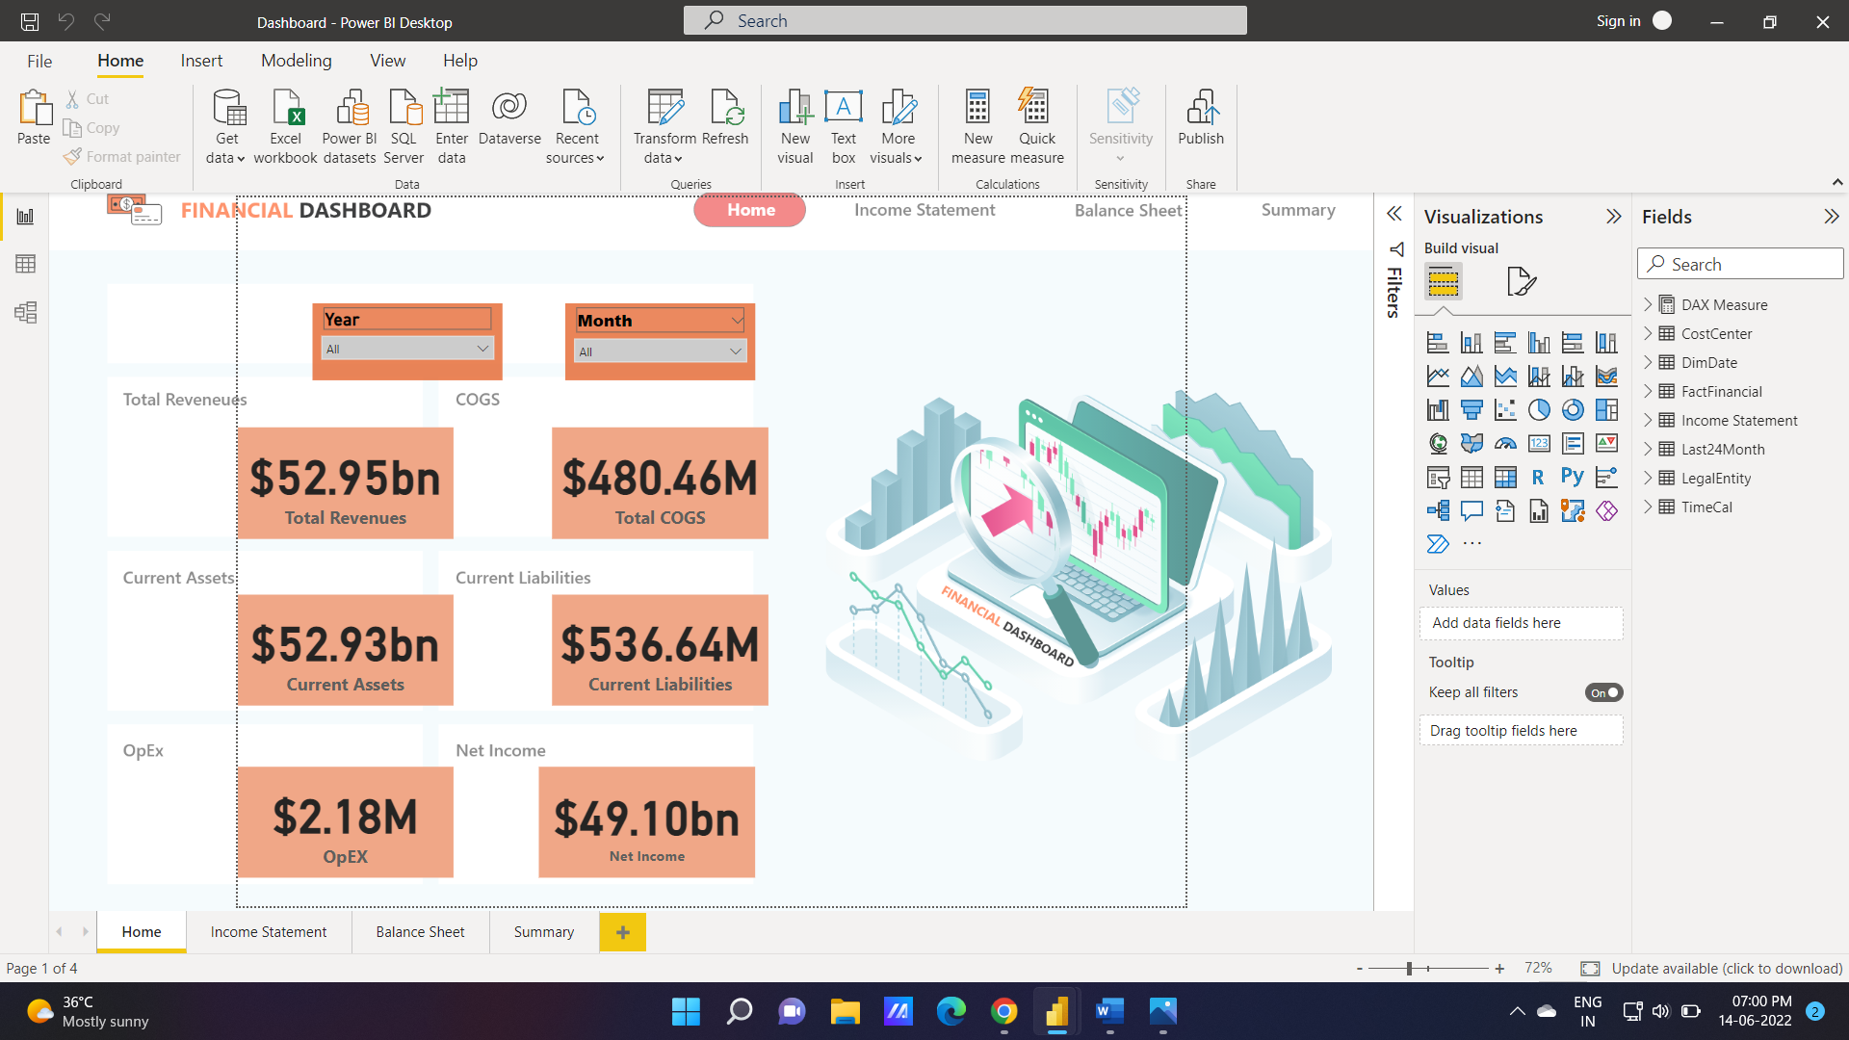

1. **COGS (Cost of Goods Sold )**

Cost of goods sold (COGS) refers to the direct costs of producing the goods sold by a company. This amount includes the cost of the materials and labor directly used to create the good. It excludes indirect expenses, such as distribution costs and sales force costs.

Total COGS = SUM ( FactFinancial[Cost] ) + 0



1. **Operating Income**

Operating income = Total Revenue – Direct Costs – Indirect Costs

OR

Operating income = Gross Profit – Operating Expenses – Depreciation – Amortization

Operating Income = [Gross Margin] - [Opex & Deprec. & Amort.] + 0

1. **Operating Income %**

Operating Income in percentage

1. **Gross Margin**

The definition of gross margin is the profitability of a [business](https://learn.financestrategists.com/finance-terms/business/) after subtracting the [cost of goods sold](https://learn.financestrategists.com/finance-terms/cogs/) from the [revenue](https://learn.financestrategists.com/finance-terms/revenue/).

It is a reflection of the amount of money a company retains for every incremental dollar earned.

1. **Gross Margin %**

Gross Margin in percentage

1. **Total Assets**

Assets are everything that a business or a company owns. This includes money, investments, equipment, or anything that has value and can be exchanged for cash. Assets are categorized into two groups: current and noncurrent. Current assets are those that are readily convertible to cash.

The definition of total assets is the sum of the value of all current and noncurrent assets.

**8. Current Liabilities**

Current liabilities are short-term financial obligations that are due either in one year or within the company’s [operating cycle](https://learn.financestrategists.com/finance-terms/operating-cycle-definition/). Current liabilities are different from long-term [liabilities](https://learn.financestrategists.com/finance-terms/liability/), which refer to debts or obligations that are due in more than a year.

Current Liabilities = SUM ( FactFinancial[CurrentLiabilities] ) + 0



1. **Liquidity Ratio**

Liquidity ratios are an important class of financial metrics used to determine a debtor's ability to pay off current debt obligations without raising external capital. Liquidity ratios measure a company's ability to pay debt obligations and its margin of safety through the calculation of metrics including the [current ratio](https://www.investopedia.com/terms/c/currentratio.asp), [quick ratio](https://www.investopedia.com/terms/q/quickratio.asp), and [operating cash flow ratio](https://www.investopedia.com/terms/o/ocfratio.asp).

1. **Debt to Equity ratio**

The debt-to-equity (D/E) ratio is used to evaluate [a company's financial leverage](https://www.investopedia.com/ask/answers/040915/what-considered-good-net-debttoequity-ratio.asp) and is calculated by dividing a company’s total liabilities by its [shareholder equity](https://www.investopedia.com/terms/s/shareholdersequity.asp).

**11. OpEx (Operating Expense)**

An operating expense is an expense a business incurs through its normal business operations. Often abbreviated as OPEX, operating expenses include rent, equipment, inventory costs, marketing, payroll, insurance, [step costs](https://www.investopedia.com/terms/s/step-costs.asp), and funds allocated for research and development.

OpEX = SUM ( FactFinancial[Expense] ) + 0



**12. OpEx to Revenues Ratio**

The Operating Expense Ratio is the ratio between the cost of operation to the net revenue. It is typically used in evaluating real estate properties, where a higher Operating Expense ratio means higher operating expense than its property income and serves as a deterrent.

**13. Current Assets**

Current assets are any [assets](https://learn.financestrategists.com/finance-terms/assets/) that can be converted into [cash](https://learn.financestrategists.com/finance-terms/what-is-meant-by-cash-definition/) within a period of one year.

This counts products that are sold for cash as well as resources that are consumed, used, or exhausted through regular [business](https://learn.financestrategists.com/finance-terms/business/) operations that are expected to provide a cash value return within a single year.

Current Assets = SUM ( FactFinancial[CurrentAsset] ) + 0



**14. Total Liabilities**

Total liabilities are the combined debts and obligations that an individual or company owes to outside parties. Everything the company owns is classified as an asset and all amounts the company owes for future obligations are recorded as liabilities.

**17. Depreciation & Amortization**

Amortization is the practice of spreading an intangible asset's cost over that asset's useful life.

Depreciation is the expensing of a fixed asset over its useful life.

**18. Total Equity**

Equity, typically referred to as shareholders' equity (or owners' equity for privately held companies), represents the amount of money that would be returned to a company's shareholders if all of the assets were liquidated and all of the company's debt was paid off in the case of liquidation. In the case of acquisition, it is the value of company sales minus any liabilities owed by the company not transferred with the sale.

**19. Interest & Taxes**

Interest is the price you pay to borrow money or the cost you charge to lend money. Interest is most often reflected as an annual percentage of the amount of a loan

Taxation refers to the fees and financial obligations imposed by a government on its residents. Income taxes are paid in almost all countries around the world. However, taxation applies to all payments of mandatory levies, including on income, corporate, property, capital gains, sales, and inheritance.

**20. Net Income**

Net income shows how much money a company is making after subtracting all [**expenses**](https://learn.financestrategists.com/finance-terms/how-to-define-expense/).

It can also be referred to as “net profit” or “the bottom line.”

Net Income is usually found at the bottom of a company’s [**income statement**](https://learn.financestrategists.com/finance-terms/income-statement/).

Net Income = [Operating Income]

- (

SUM ( FactFinancial[Tax] ) + SUM ( FactFinancial[interest] ) + 0

)

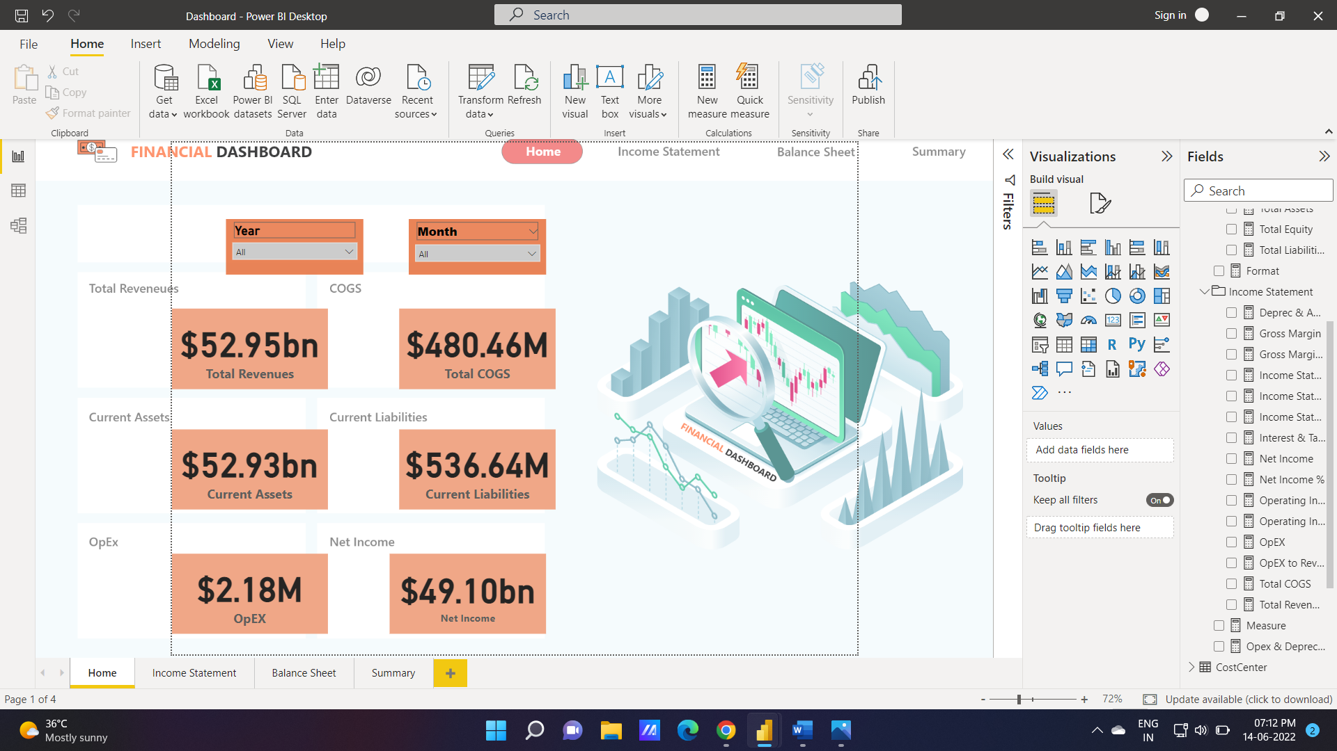

**21. Net Income %**

Net income in percentage

1. **Visualization and Result:**
2. **Home:**

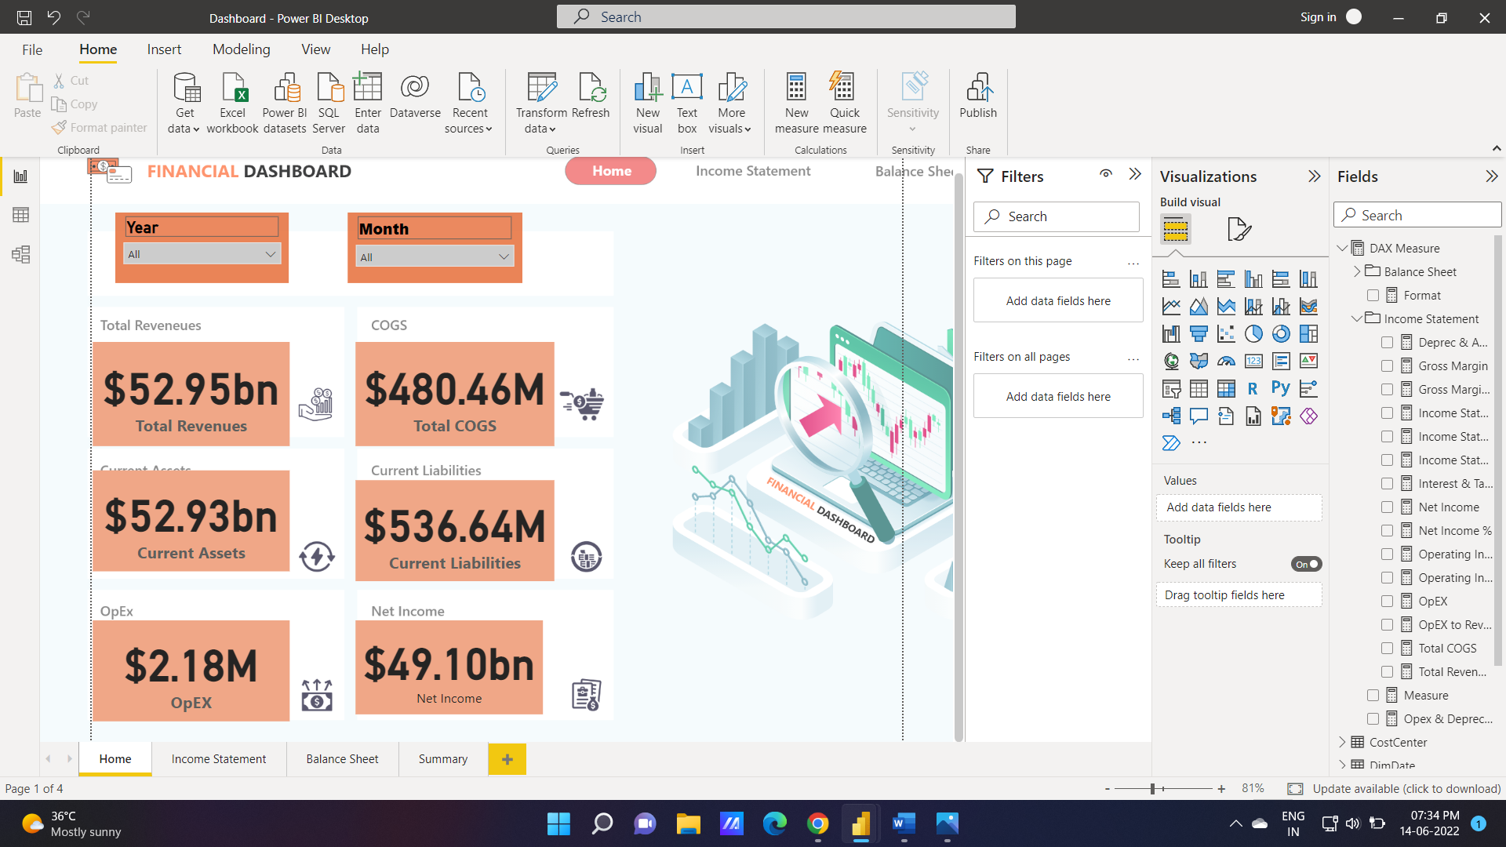

1. **Balance Sheet:**

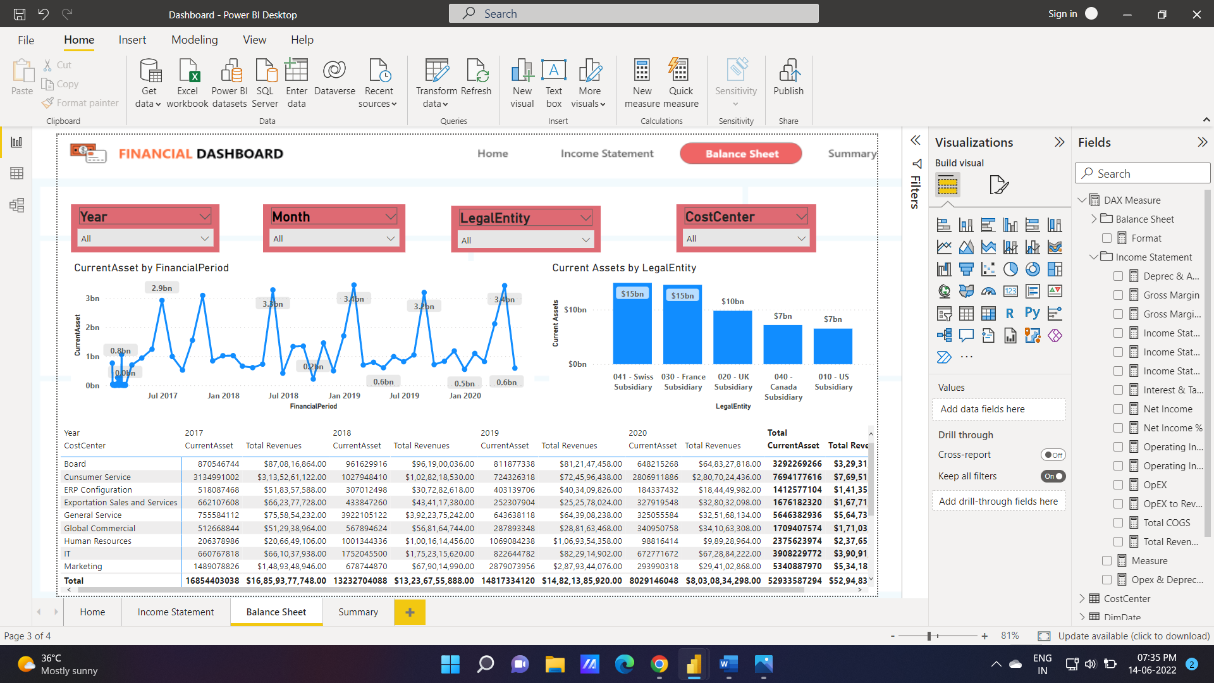

1. **Income Statement:**

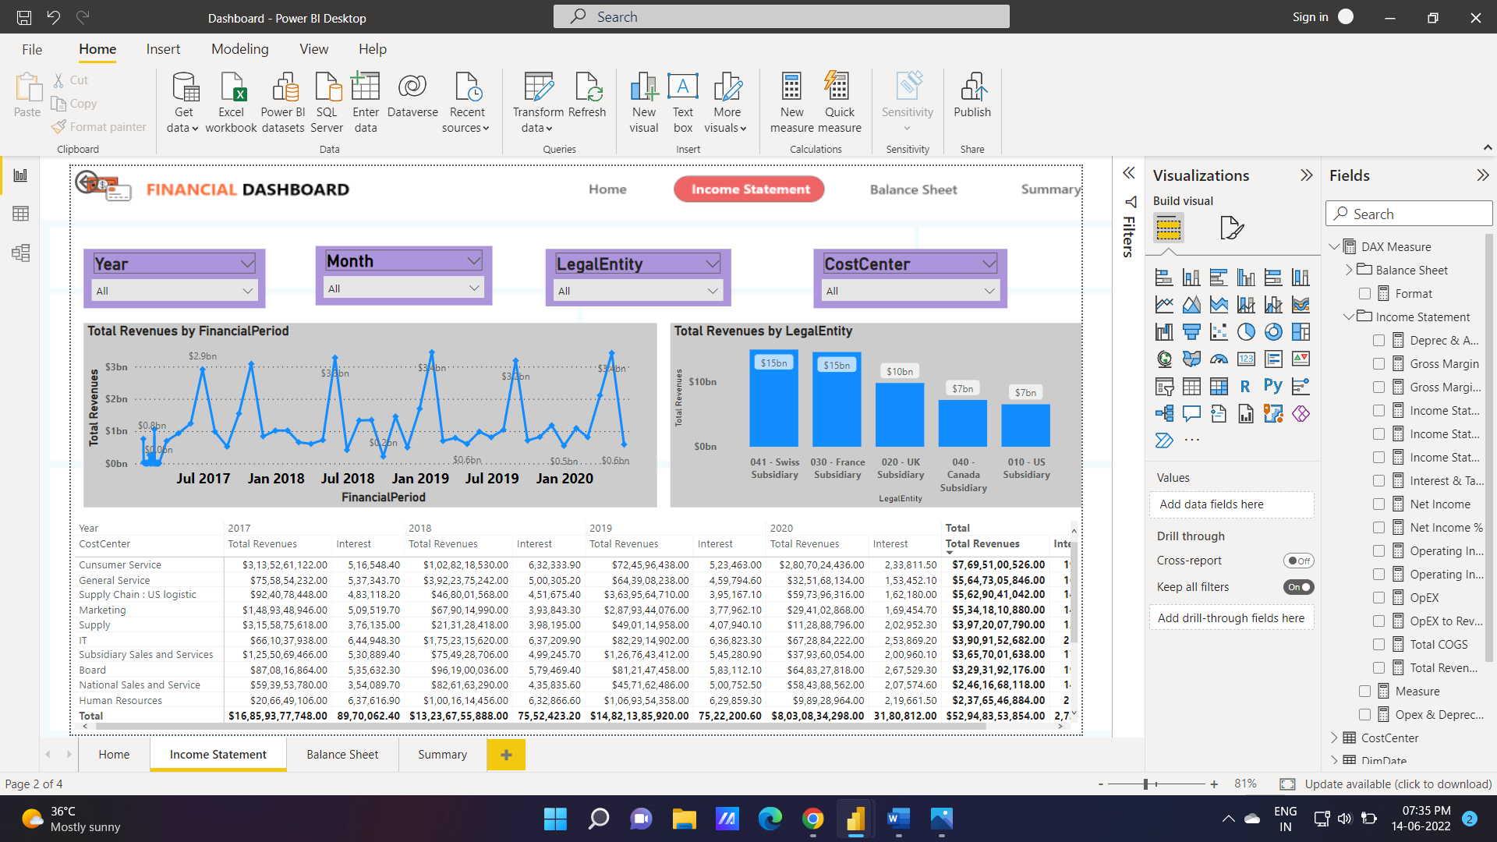

1. **Cockpit Analysis:**

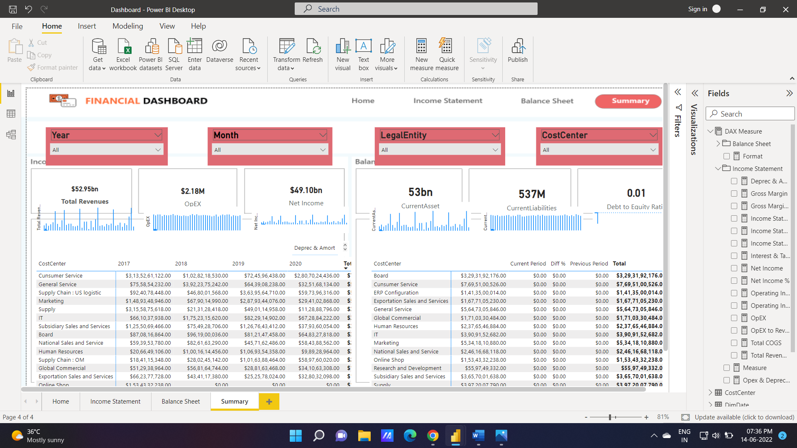

1. **Conclusion:**

Empowered by the latest data visualization techniques, Power BI dashboards are among the most effective resources for use by financial and accounting experts. As outlined in this write-up, a financial operations dashboard in Power BI can be developed with key finance-related metrics and KPIs.

1. **Future Work:**

* A financial operations dashboard in Power BI is beneficial in rendering key pieces of financial data in the graphical or visualized format
* Provides a means of communicating the key financial metrics of your Balance Sheet across time, in order to ensure long-term viability and success.
* Presents an effective means of monitoring your assets and liabilities, thus providing a means to evaluate the capital structure of your company.
* Provides a means of communicating the figures of your Income Statement across time, in conjunction with relevant financial metrics.
* Visualises the Income and Expenses, and thus profitability of your company’s operations, and communicates month-to-date and year-to-date statistics of your financial figures against your budgeted and forecasted figures.